# Design Planning Techniques (Low – High Fidelity prototypes)

As a fourth stage of design thinking process **prototype** is one of the most important stages, especially because user or customer is finally involved. At this stage customer will receive some idea or rough model of what it’s going to look like, at this stage customer can add some requirements and specifications.

A **prototype** is a draft version of a future product that can help to explore any ideas and describe a particular feature or the overall design concept to users. It is important to do this stage before any proper design developing started. There are two types of prototypes **high-fidelity** (fully functioning site/template with some functionality) and **low-fidelity** (usually paper drawings). <https://www.visual-paradigm.com/guide/ux-design/wireframe-vs-storyboard-vs-wireflow-vs-mockup-vs-prototyping/>

## High-fidelity prototyping

High-fidelity prototyping is an interactive representation of the future product in its closest similarity to the final design, including colors, details, and functionality”. The “high” refers to the level of fullness that allows to examine usability questions in detail and make conclusions about the user’s behavior. High-fidelity prototypes look very similar to the end product.

**Advantages of high-fidelity prototypes**

* More interaction for the user.
* Likeliness of a user to navigate and work through a product on themselves with not much help from a designer.
* The closer to the completion of the product, the clearer the designer sees the final product
* Stakeholders able to see final product, after revision they can finalize some aspects of design to be changed.

**Disadvantages of high-fidelity prototypes**

* Takes more time to produce
* User might go to deep into details and ask to many questions about some minor things, because product looks almost finish and very realistic.
* At this stage it is very hard for designers to take criticism and implement changes for their working prototype.

Both prototype methods are often applied on the same product, with low-fidelity prototypes at the start of project and high-fidelity prototypes towards the end when reviews and tests become more refined.

<https://blog.prototypr.io/high-fidelity-prototyping-what-when-why-and-how-f5bbde6a7fd4>

### Example of high-fidelity prototype.

Very good example of a high-fidelity prototype is Mockup. It is static design for representing a future product. Mockup is representation of an actual final screen, where wireframe shows only a structure. This design helps to make a final decision about color schemes or layout of elements, but at this stage it is still not clickable or interactive. It also helps to give the user a more realistic impression of a final product. Despite lack a functional part, mockup can provide a final look for a customer, sometimes that is all what they want to see.

<https://www.visual-paradigm.com/guide/ux-design/wireframe-vs-storyboard-vs-wireflow-vs-mockup-vs-prototyping/>

## Low-fidelity prototype

Low-fidelity prototype represent a kind of sketch or paper model of the future product. With this model the client can interact and start making their own adjustments, which will be installed in high-fidelity prototype.

**Advantages of low-fidelity prototypes**

* Fast
* Inexpensive
* Can be changed very quickly
* Disposable
* Helps the designer to see a whole overview of a future product
* anyone can make a low-fidelity prototype, even unexperienced person
* Fosters design thinking

**Disadvantages of low-fidelity prototypes**

* Not realistic
* Bad quality and accuracy prototypes may lack validity
* May not be applicable for some products
* Some help from a designer might be necessary when user is going to interact with a prototype

https://www.workshopper.com/post/design-thinking-phase-4-everything-you-need-to-know-about-prototyping

### Examples of low-fidelity prototypes:

### Sketching

Sketching is a low fidelity prototype method that can help to visualize at the very beginning of developing process. Can be done by pencil and paper. Wireframe and storyboarding are based on sketching.

### Storyboarding

A storyboard is a visual representation of the scenes, dialogs, action in a sequential specific order. It is a method used to imitate ideas, designs and concepts for websites usually by presenting a sequence of wireframes in a order which could be already developed in the earlier development stage.

Storyboards can help to get a visual overview of a product. This is especially useful when creating a game that might contains many steps. This is a very quick way to see what game will look like before prototype or test it. Storyboarding the interaction between game history and different gameplays is an easy way to unravel problem areas before they appear in the expensive development phase.

<https://www.visual-paradigm.com/guide/ux-design/wireframe-vs-storyboard-vs-wireflow-vs-mockup-vs-prototyping/>

### Storyboard for game

At the very beginning of storyboard is creating "cards" that would describe plot points and events. Each card might be a few lines of text, script, a scribbled-down idea, or a sketch of a scene or even just a picture.

To accomplish the best result in creating a storyboard card some tactics might be handy.

First tactic is to create cards that would describe plot and idea. For example:

* **Primary Event Cards**
* **Secondary Event Cards**
* **Gameplay Event Cards**
* **Bonus Cards**
* **Character, attributes (sword for example)**
* Bosses or battle stage

Second tactic is to organize the board. Once all the story cards are created, it's time to put them into order. It is very important to start from somewhere, even if order is wrong, it is very easy to fix it by just shifting the around until desired result is achieved. It can be dome in Chronological Order or State or Sequence Order.

Third tactic or step is **review** and **revise.** After some “playing” with a cards, putting them in different order it is important to step back and review what is accomplished so far. Some feedback on what have been accomplished is required.

<https://gamescrye.com/blog/how-to-storyboard-your-game/>

## Wireframe

A wireframe is a sketch design of the future system, which must be fulfilled before any design work is started. Through clearness and simplicity, it allows anyone to read and understand it easily. Wireframe shows information with not many details, but enough to see a full picture and visualize a future product. At this method scenario can be showed to a customer for a future specialization and list of requirements from a customer. Wireframe can be called a blueprint, as it defines structure, content and functionality.

Benefits of wireframing are**:**

* Wireframes are easy to draw. Can be completed by pencil and paper
* Usually, it is easy to understand wireframes
* Easy to modify.
* No coding needed.
* In-line annotations. Specification and annotations can be showed on sketches.

<https://www.visual-paradigm.com/guide/ux-design/wireframe-vs-storyboard-vs-wireflow-vs-mockup-vs-prototyping/>

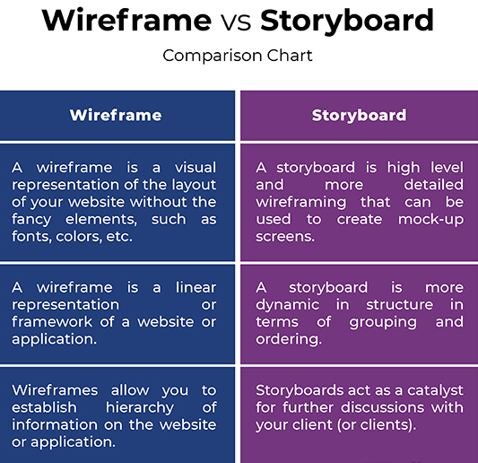

<http://www.differencebetween.net/technology/difference-between-wireframe-and-storyboard/#:~:text=A%20storyboard%20is%20quite%20similar,goes%20further%20inside%20the%20application>.

### Paper prototyping

Paper prototyping is a good way to create and test new designs in a short period of time. If paper prototype used correctly, it can provide maximum learning for minimum effort. Paper prototype a mix of techniques such as drawing, simulating, testing in according to create quickly “interface” for an user to interact with.

### Cons of Paper Prototyping.

* **User interaction at an early stage**
* **Cheap**
* **Encourages creativeness and imagination**
* **No design or coding skills required**
* **Minimum resources needed**
* **Fast evaluation and testing**
* **Assists in documentation**
* **Very popular in IT industry**

<https://usabilitygeek.com/paper-prototyping-as-a-usability-testing-technique/>

### Disadvantages of a paper prototypes.

* Might be hard to explain design.
* No testing online, only in person
* **Limited context and interaction**



<https://uxplanet.org/the-magic-of-paper-prototyping-51693eac6bc3>

### Summary

Wireframes and storyboards are verry similar, they basically follow the same pattern of navigation scheme and layout with no visual elements, thereby make life of web designers and web developers easier. Both wireframing and storyboarding are proposed techniques that are applied at very early stages as prerequisites in the web development process. However, storyboarding can be called - high level wireframing with better representation, sketches, layouts to share with the client to make sure that everybody is on the same page and work toward a goal. Wireframe and storyboard are playing one of the most crucial parts in UX deliverables of web development lifecycle.  
<http://www.differencebetween.net/technology/difference-between-wireframe-and-storyboard/#:~:text=A%20storyboard%20is%20quite%20similar,goes%20further%20inside%20the%20application>.